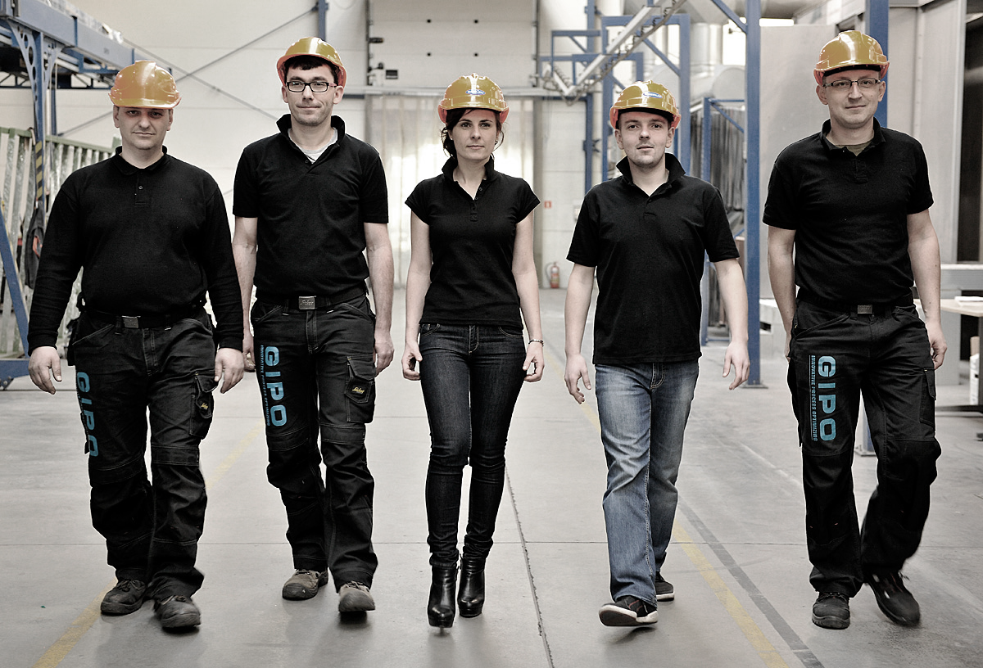
  - Do You want to create sth completely new? Are You innovative and ready for new challenges? Would You like to develop software of a new warehouse system? If so, we are looking for You!
Software Developer

Company introduction
GIPO and FlexAgile Systems joined on one mutual mission. Together we develop an automatic warehouse system named eStore. We work hard and inspire our team members to be creative and entrepreneurial. We deliver quality and stability in our solutions.

Job description
You will participate from the project’s very beginning. Your tasks and
responsibilities will be defined in close collaboration with our project manager who is the conceptual founder of the system. Other than that you are on your own. We therefore expect you can take initiative and think entrepreneurial. We rely on your skills and will to be successful.

Responsibilities:
Optimizing hardware and software
Controlling motordrivers
Developing a loop control
Connectivity and data transfer
Routing and driving
Ongoing tests and improvements

Skills:
Software Engineer, alternatively Student
Linux RTOS and Windows OS
Familiar with LabView-FPGA and sbRIO
English in speech and writing

Benefits
We offer the rare opportunity to change the world and reinvent logistics. We
believe the right candidate will grow with the company and have a vital role in the future.
We’ll negotiate your salary according to your qualifications.

Apply now!
If you would like to join us - then send an application and your CV to work@gipo.eu

When applying please enclose the below statement:
”I hereby give consent for my personal data included in my application to be processed for the purposes of the recruitment process under the Personal Data Protection Act as of 29 August 1997, consolidated text: Journal of Laws 2002, item 1182 as amended.”

